***TA Portfolio for CSE 599***

**Student : Srinath Narayanan**

**PID : A53213478**

**Course TA’ing for : CSE 258, under Dr. McAuley**

**Table of Contents**

[TA journal](#_nhqm9vh556gl)

[Teaching observations and feedback](#_shtsmfx30s0b)

[Micro-video](#_iyw3hr7pv9hp)

[Micro-teaching / Discussion section feedback](#_q227f5nrh54a)

[Observing Micro-teaching / Discussion section](#_ideddnohkvbm)

[Summary of teaching observations](#_3mm5t2rxgdnw)

[Optional: Reflections on main themes](#_uhupej765v2k)

[Jot down notes on CSE 599 topics and their connections to your experience](#_h5cm9qjai8sg)

### TA journal

*Time spent? Celebrate! What can be improved?*

Pre-quarter set-up / Week 0:

**<<Include link to PDF / screen shot / summary of completed ASES form>>**

**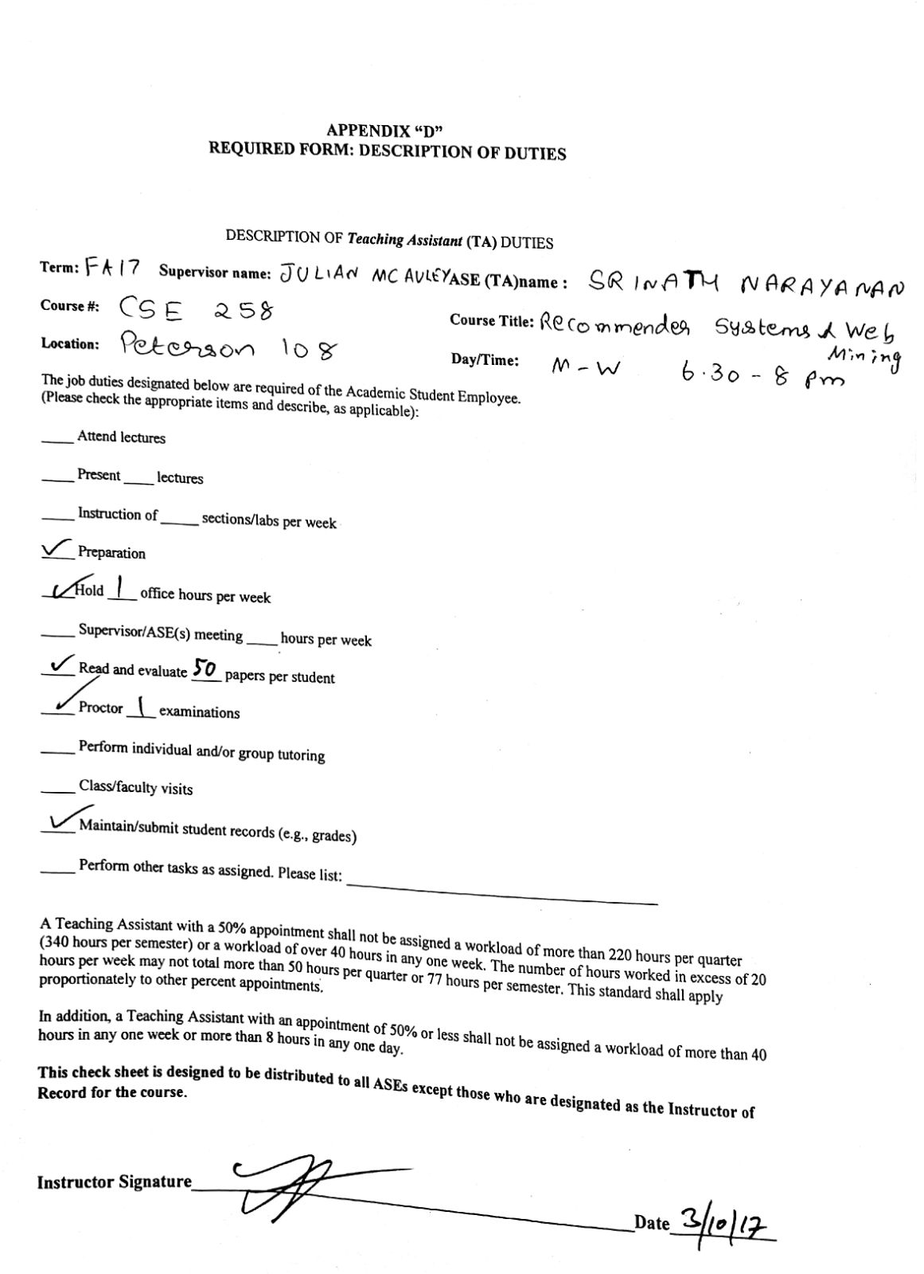**

**Week 1:**

Hours spent :

* Piazza - Wrote syllabus, office hours, introduction, and setup student accounts - 2 hours
* Attended lectures - 4 hours
* Piazza - Answered 4-5 questions after through research - 2 hours

Victory of the week :

* I was able to convince a student that her preconception was incorrect, and showed her a good analogue that convinced her why that path shouldn’t be followed and why it is flawed. She seemed really happy about the answer and thanked me. I was happy that I was able to correctly justify my position as a TA not only from the technical stand-point but also from the inter-personal skill stand-point.

Opportunities :

* I should have introduced myself better during the 1st class meeting. Since the Professor caught me off-guard while introducing me, I just stood up and let the Professor introduce me. Since he didn’t know much about my background, he couldn’t give a proper introduction, and the students might not have felt any connect. I believe the first impression is very important and hence I should have practiced it before.

Plans for next week :

* I plan to be more concise and not waste student’s time. I sometime go overboard with enthusiasm and try to give multiple examples, effectively confusing the student. Hence, I plan to be more thoughtful of what I say and make sure the student understands the answer.
* I also plan to ask thought-provoking and doubt-inducing questions which I believe will intrigue the student, to find his/her own answers, and improve the understanding of the subject.

**Week 2:**

Hours spent :

Piazza - 3 hours - Answered questions, cleared doubts and attended to issues with homework

Lecture prep - 2 hours

Homework assistance - 4 hours

Victory :

* Helped students understand a difficult issue with the homework. They had to apply a new technique to get a solution with the given data and that proved to be a hassle to implement. I was able to guide them to the right resources to handle the problem.
* Introduced them to cross-validation and bagging approaches

Opportunities :

* My co-TA missed her TA session by an hour. She had forgot to attend it, and the students complained that the room was empty in Piazza. I attended to their concerns and called the TA to remind her of the session. I also arranged a new room for an extended TA session to account for the time lost.

Plans :

* My TA session is upcoming so I need to prepare for it. Homework 1 submission deadline is up, and hence I plan to implement Homework 1 myself and get ready for grading next week by studying rubrics and attending to other issues with homework

**Week 3:**

Hours spent :

Piazza - 3 hours - Answered questions, cleared doubts and attended to issues with homework

Lecture prep - 2 hours

Homework assistance - 4 hours

Prepared Midterms - 2 hours

Held office hours - 3 hours

Victory :

* Helped students with the homework.
* Successfully held office hours.
* Graded HW1 with only 3 regrade requests out of 300 students

Opportunities :

* Had a great opportunity to talk to students, understand their inhibitions etc, during office hours..

Plans :

* Prepare for Homework 2. Prepare for midterm.

**Week 4:**

Hours spent :

Piazza - 3 hours - Answered questions, cleared doubts and attended to issues with homework

Homework assistance - 4 hours

Prepared Midterms - 8 hours

Held office hours - 3 hours

Victory :

* Helped students with the homework.
* Successfully held office hours.
* Prepared midterm questions. Brainstormed with other TAs

Opportunities :

* Had a great meeting session with the instructors regarding midterm. Came up with innovative ideas on how to construct intriguing questions.

Plans :

* Prepare for midterm and help more students with the subject.

**Week 5:**

Hours spent :

Piazza - 5 hours - Answered questions, cleared doubts and attended to issues with homework

Homework assistance - 2 hours

Prepared Midterms - 2 hours

Grading - 8 hours

Victory :

* Submitted interesting questions to the midterm corpus. 2/3 questions got picked by Professor.
* Volunteered to proctor midterm for a student in need of assistance from the OSD office.

Opportunities :

* Created midterm questions that were intuitive, and I believe the students will find it intriguing and interesting.

Plans :

* Proctor midterm and help students, and grade midterms.

**Week 6:**

Hours spent :

Piazza - 2 hours - Answered questions, cleared doubts and attended to issues with homework

Homework assistance - 2 hours

Midterms proctoring - 2 hours

Midterm grading - 8 hours

Homework Grading - 4 hours

Victory :

* Successfully conducted midterm and graded the questions
* Helped a student with assignment codes.

Opportunities :

* Conducted a kaggle competition with data mining and recommendation system tasks.

Plans :

* Open midterm for regrades. Grade homeworks. Attend to piazza. Rough next couple of weeks.

Issue :

* Our Professor had reported a few students who were egregious in the submission of their midterms on time. They took nearly 10 min after the final call, and were noted down. The Professor asked for our opinion, and I suggested that we make a Piazza post and call out the issue (not naming students, of course), and make the Homework 4 compulsory for the reported students (It is optional for others).

Week 7:

Hours spent :

Piazza - 5 hours - Answered questions, cleared doubts and attended to issues with homework

Homework assistance - 2 hours

Homework Grading - 4 hours

Practical assignment 1, coding / help - 4 hours

Victory :

* Successfully conducted the practical Assg 1 - dealing with latent factor models for price prediction. Introduced a tricky concept and helped students code in office hours
* Successfully graded midterm and Hw3.

Opportunities :

* Had a lot of opportunity to interact with students for more than 4 hours, planning and executing PAs.

Plans :

* Finish Assg1 grading. Prepare for Assg2.

Week 8:

Hours spent :

Piazza - 2 hours

Office hours - 3 hours

Victory :

* Helped students with submission of Assg 1 on Monday.

Opportunities :

* Had a taste of being flooded with regrade requests

Plans :

* Not much. Just be open on Piazza during Thanksgiving holidays and help students on Assg2 and HW4 submissions.

Week 9:

Hours spent :

Piazza - 6 hours

Office hours - 1 hours

Victory :

* Designed questions for Assignment 2

Opportunities :

* Worked towards end-of-quarter requirements

Plans :

* Grading Assignment 2. Clean up grades, query students about regrades requests with any serious errors and finalize grades for all except Assg2

Week 10:

Hours spent :

Piazza - 2 hours

Grading - 8 hours

Victory :

* Helped students with submission of Assg 2 on Monday.

Opportunities :

* Provided students with thoughts on paper ideas for Assg2. Brainstormed, designed and walked through solutions.

Plans :

* Grade Assg2. Finish up class grades and send to Professor. Urge students to fill in course and instructor feedbacks.

### 

**Week 9 Practicum:**

**Question that kept me busy :** Implementing a latent factor model with higher dimensional latent spaces for review prediction.

1. **Context** : The question appeared in the practical assignment 1 of the course. In HW3 we had a easier version of the question with 1D latent spaces that the students were directly able to solve. Since we extended it to multiple dimensions, it was tough to get an intuitive sense of the answer.
2. **The hard thing about the question** : It was its convergence. The algorithm is extremely volatile in the sense that, it would easily converge to a local minima, if not diverge, when it is not initialized properly. Also since it is a multi-dimensional case we need to take care in writing out the equations, since the latent-terms are not jointly Gaussian.
3. **Office hours** : I was able to lead the students to better initialization methods and convergence techniques, and to an acceptable answer. I truly believed that the office hour before the assignment submission, helped them a lot.

### 

### Teaching observations and feedback

#### Micro-video

**<<Include link to video>>**

[**https://www.youtube.com/watch?v=3XziAVxPCrI**](https://www.youtube.com/watch?v=3XziAVxPCrI)

**<<Include PDF / screenshot / summary of completed Teaching Feedback Form>>**

**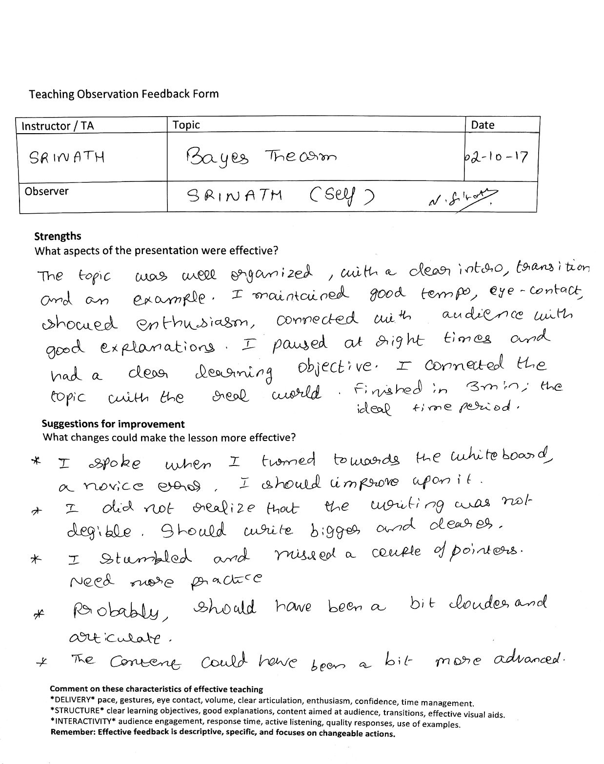**

#### Micro-teaching / Discussion section feedback

1. Week 02: observed by Group 8 members

**<<Include PDF / screenshot / summary of each completed Teaching Feedback Form you received during this teaching session; for practicum sessions, you should have at least 4 feedback forms>>**

**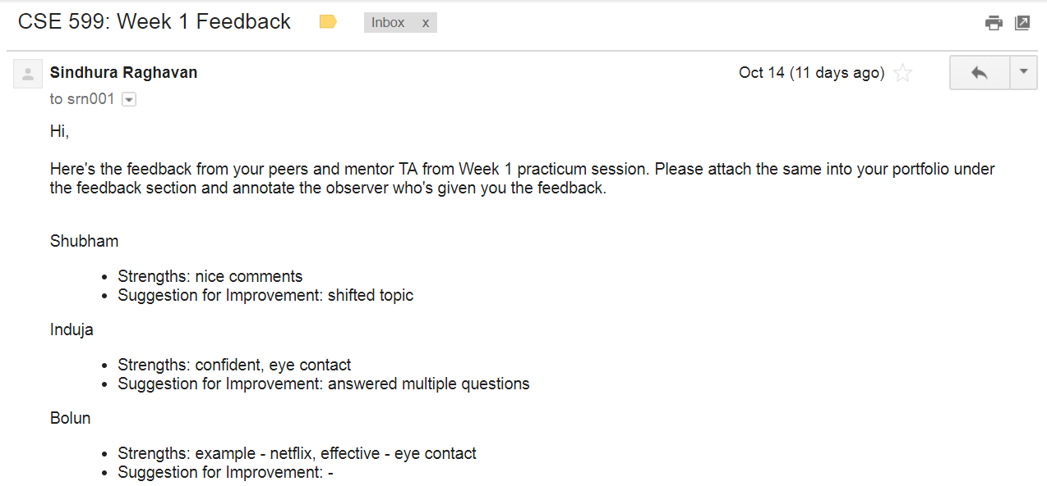**

1. Week 04: observed by Group 8 members

**<<Include PDF / screenshot / summary of each completed Teaching Feedback Form; for practicum sessions, you should have at least 4 feedback forms>>**

Bolan -

Strengths - Clear articulation and organized lecture.

Suggestions - Pace was fast. Less content for 5 minutes

Shubham -

Strengths - Well prepared

Suggestions - Went too fast. Need to be slower

Srinath (self) -

Strengths - Eye contact was good. Good use of white board

Suggestions - Lots of jumps between concepts since I was too excited. Tried to

cramp the concept in.

Indija -

Strengths - Great articulation. Good response to questions. Time management

and confidence.

Suggestions - Fast paced. Probably needed a stronger objective

Chester -

Strengths - Clear examples

Suggestions - Too rigorous approach

*May include more than 2!*

#### Observing Micro-teaching / Discussion section

1. Week XX: observed \_\_\_\_\_\_\_\_\_\_\_\_.

**<<Include PDF / screenshot / summary of completed Teaching Feedback Form>>**

1. Week XX: observed \_\_\_\_\_\_\_\_\_\_\_\_.

**<<Include PDF / screenshot / summary of completed Teaching Feedback Form>>**

*May include more than 2!*

#### Summary of teaching observations

Week 4 : How people learn - Learning objectives for CSE 258

### IMG_20171101_223749.jpg

### 

### Optional: Reflections on main themes

*Jot down notes on CSE 599 topics and their connections to your experience*

#### How People Learn

1. People learn by repetition and sustained suggestions
2. Should evoke a response from a student and not present answer in a platter

#### Communication and Feedback

1. Very important to understand the energy and intent of a student. Does she/he have a difficulty with a concept / a particular question / or the subject in general, and how do we do about solving it.
2. Stay within realms of professional TA decorum
3. Suggest changes, have an implicit feedback to the student. Don’t be harsh in your comments; even incidentally.

#### Assessment

1. Very important to have a strong set of rubrics with instructor approval.
2. Fair grading is extremely important. Fair in terms of following rubrics, spending time on the paper, suggestions, and no nitpicking.

#### Inclusiveness

1. Evoke a response from all students. Make sure not to discourage enthusiastic ones, and still try to make the quiet ones respond.
2. Make sure to understand the implicit biases, the stereotypes and the support systems the students hold dear, and try to work around them in a professional way.